Investigation Electromagnetic Field distribution in Rectangular to Circular Waveguide transition.
Test Case 1:
Analyse the electric field and magnetic field distribution at Port 1of the rectangular waveguide circular waveguide transition and examine the electric and magnetic field parameters at Port studying electromagnetic field behaviour and validating the system performance.

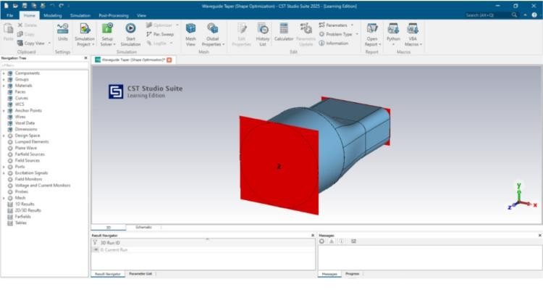
Output:
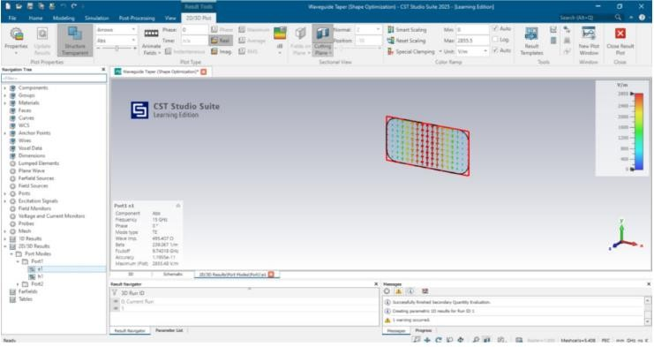
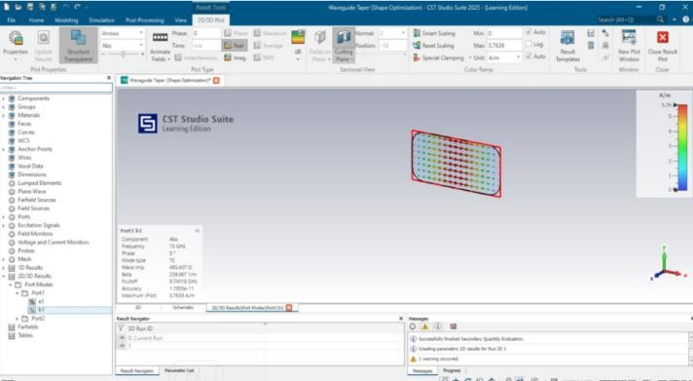
Test Case 2:
Simulate a linear tapered Rectangular Waveguide using CST Studio Suite, analyze its electromagnetic behavior, and examine the S parameters.


Output:
